CHILDREN'S ANEMIA IN NIGERIA
Comprehensive Data Analysis Report
Analysis of 2018 Nigeria Demographic and Health Survey (NDHS)

Executive Summary
This report presents a comprehensive analysis of childhood anemia in Nigeria using representative data from the 2018 Nigeria Demographic and Health Survey (NDHS). The analysis examines 10,182 children aged 0-59 months with valid child hemoglobin measurements.

Key Findings:
- 68.8% of Nigerian children under 5years experience some level of anemia.
- Anemia is strongly associated with household socioeconomic factors.
- Wealth disparities are dramatic: 79.5% of poorest children are anemic vs. 53.5% of richest.
- Rural children face significantly higher anemia burden (72.9%) compared to urban (62.3%).
- Early childhood anemia remains a critical public health challenge requiring targeted interventions.

Research Question
How are household socioeconomic factors (wealth, maternal education, residence type) associated with anemia prevalence among children aged 0-59 months in Nigeria?

Methodology
Data Source
The analysis utilizes cross-sectional data from the 2018 Nigeria Demographic and Health Survey (NDHS), a nationally representative household survey covering all 36 Nigerian states plus the Federal Capital Territory (FCT). The target population includes children aged 0-59 months and their mothers aged 15-49 years.
Sample Size and Data Completeness
Metric | Value
Total Records in Dataset | 33,924
Records with Valid Anemia Data | 10,182 (30.0%)
Analysis Sample | Children with complete child hemoglobin measurements

Variables Analyzed
Note on outcome variable: the dataset contains two hemoglobin/anemia fields. "Hemoglobin level adjusted for altitude and smoking" applies only to adult respondents (mothers), the smoking adjustment has no meaning for a child. The child-specific field is "Hemoglobin level adjusted for altitude" (no smoking term), paired with the second "Anemia level" column. This report uses that child-specific field throughout.

Dependent variable (Primary Outcome):
- Child Anemia Level (Not anemic, Mild, Moderate, Severe)
Independent Variables:
- Household Wealth Index (5 categories: Poorest to Richest).
- Maternal Education Level (No education, Primary, Secondary, Higher).
- Type of Residence (Urban vs. Rural).
- Bed Net Usage (Yes/No).
- Iron Supplementation Status (Yes/No/Unknown).

Analysis Approach
Descriptive statistics was used for the analysis to examine the association between socioeconomic factors and child anemia prevalence. Percentages are calculated within each category to allow for direct comparison of anemia burden across groups.

Findings
- Overall Anemia Burden
Among the 10,182 children with valid anemia data, 68.8% (n=7,003) experience some level of anemia. Moderate anemia is the most common form, affecting 38.6% of children, followed by mild anemia (27.0%). Severe anemia is uncommon but not negligible, affecting 3.2% of the population.

- Anemia and Household Wealth
Household wealth emerges as the strongest predictor of child anemia risk. Children from the poorest households have an anemia rate of 79.5%, compared to 53.5% in the richest households, a difference of 26.0 percentage points.This gradient is consistent across all wealth quintiles, with anemia declining steadily as household wealth increases.

The clear inverse relationship between wealth and anemia prevalence suggests that targeted interventions focusing on poor households could significantly reduce childhood anemia in Nigeria.

- Anemia and Maternal Education
Maternal education shows a strong negative association with childhood anemia. Children whose mothers have no formal education have a 75.8% anemia prevalence rate, while children of mothers with higher education have a 49.0% rate, a gap of 26.8 percentage points. The protective effect of education likely operates through improved nutrition knowledge and healthcare-seeking behavior.

Educational interventions and programs targeting mothers could be an effective strategy for reducing childhood anemia, particularly in improving awareness about iron-rich foods and supplementation.

- Urban-Rural Disparities
Significant geographic disparities exist in childhood anemia prevalence. Rural children experience anemia at a rate of 72.9%, compared to 62.3% in urban areas a difference of 10.6 percentage points. This gap likely reflects limited healthcare infrastructure and reduced access to nutritious foods in rural areas.

- Anemia Severity Distribution
When examining the severity of anemia by wealth quintile, a clear pattern emerges: not only are the poorest children more likely to be anemic, but their anemia is also more likely to be moderate or severe. In the poorest quintile, 48.1% have moderate anemia and 5.8% have severe anemia, compared to 23.5% and 0.5% respectively in the richest quintile.
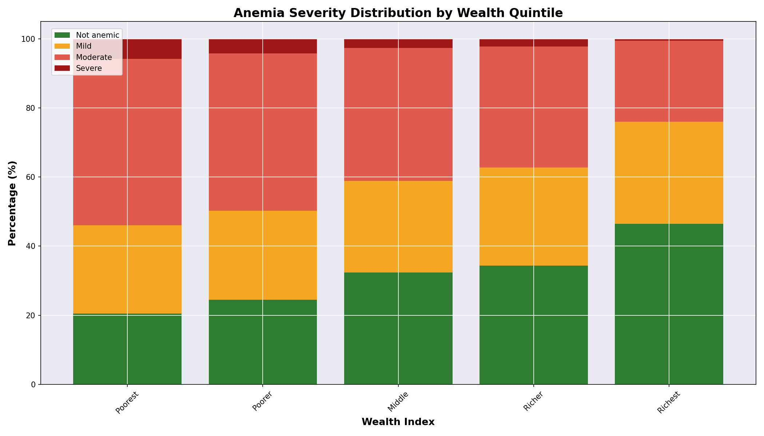

Discussion (Key Takeaways)
- Magnitude: Nearly 7 in 10 Nigerian children under 5 are anemic—a substantial public health burden.
- Equity Issue: Anemia in Nigeria is fundamentally an equity problem. It is concentrated among children from poor, rural, and less-educated households.
- Multiple Pathways: The associations with education, wealth, and residence suggest that multiple interconnected factors drive childhood anemia—poor nutrition, limited healthcare access, higher infection burden, and lower health literacy.
- Prevention-Oriented Approach: The strong socioeconomic gradients suggest that broad-based poverty reduction, education, and rural healthcare infrastructure improvements could reduce childhood anemia.

Limitations
- Cross-sectional Design: This analysis cannot establish causation, only association.
- Missing Data: 70.0% of records lack a valid child hemoglobin measurement (children were only tested in households selected for anemia testing, and those under 6 months are excluded from testing), potentially introducing bias. This is a large gap and results should be read as describing the tested subsample, not guaranteed to generalize to all children.
- Unmeasured Confounders: We cannot account for all factors affecting anemia (diet quality, infection history).
- Survey Design: The DHS clustered sampling design is not accounted for; standard errors may be underestimated.

Implications for Action
For Policy Makers:
- Prioritize anemia reduction in poor and rural areas through targeted health programs.
- Strengthen primary healthcare infrastructure in rural Nigeria.
- Implement mass iron supplementation programs targeting high-risk populations.
For Public Health Programs:
- Integrate anemia screening and treatment into routine maternal and child health services.
- Develop context-appropriate nutrition education emphasizing iron-rich foods.
- Address malaria control to reduce one driver of anemia.
For Future Research:
- Investigate the specific mechanisms linking education and wealth to anemia.
- Examine the role of dietary patterns and food access.
- Evaluate the impact of targeted interventions in high-burden populations
Conclusion
Childhood anemia in Nigeria is a preventable condition that remains concentrated among the poorest and least educated families. The strong associations with household wealth, maternal education, and rural residence indicate that addressing childhood anemia requires comprehensive approaches that tackle underlying socioeconomic determinants. While targeted clinical interventions are important, meaningful progress will require investment in poverty reduction, education, and equitable healthcare access.
The 2018 NDHS data demonstrate that Nigeria has the tools and knowledge to address childhood anemia. What is needed is sustained commitment to implementing evidence-based strategies and ensuring that interventions reach the most vulnerable children.

